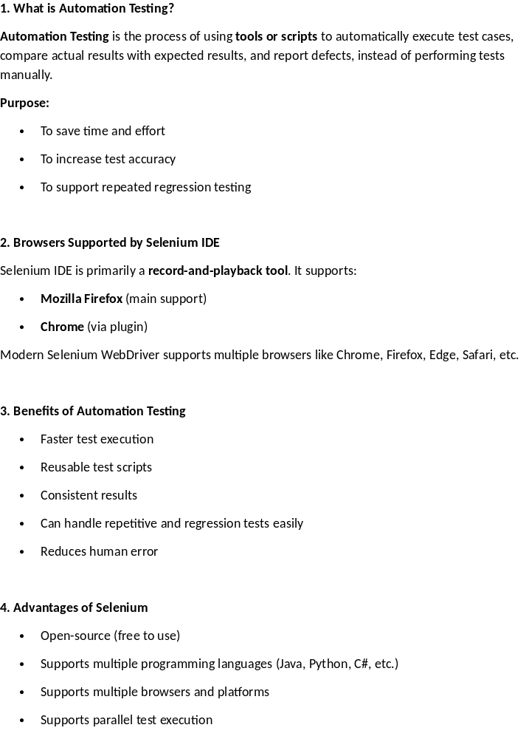2. Browsers Supported by Selenium IDE
Selenium IDE is primarily a record-and-playback tool. It supports:
- Mozilla Firefox (main support)
- Chrome (via plugin)
Modern Selenium WebDriver supports multiple browsers like Chrome, Firefox, Edge, Safari, etc.

3. Benefits of Automation Testing
- Faster test execution
- Reusable test scripts
- Consistent results
- Can handle repetitive and regression tests easily
- Reduces human error

4. Advantages of Selenium
- Open-source (free to use)
- Supports multiple programming languages (Java, Python, C#, etc.)
- Supports multiple browsers and platforms
- Supports parallel test execution
- Large community and documentation

5. Why choose Selenium over QTP?
Selenium | QTP (UFT)
Free and open-source | Paid tool
Supports multiple browsers | Limited browser support
Supports multiple programming languages | Primarily VBScript
Cross-platform support | Windows only
Flexible integration with frameworks | Limited integration options
Selenium is preferred for web automation in diverse environments.

6. Test Scenario Example: Validate “Contact Us” Page on TOPS Technologies Website
Steps using Selenium (High-Level):
